**FoxMaster 2400 (Type：H283007ARC-250A) RS-SV**

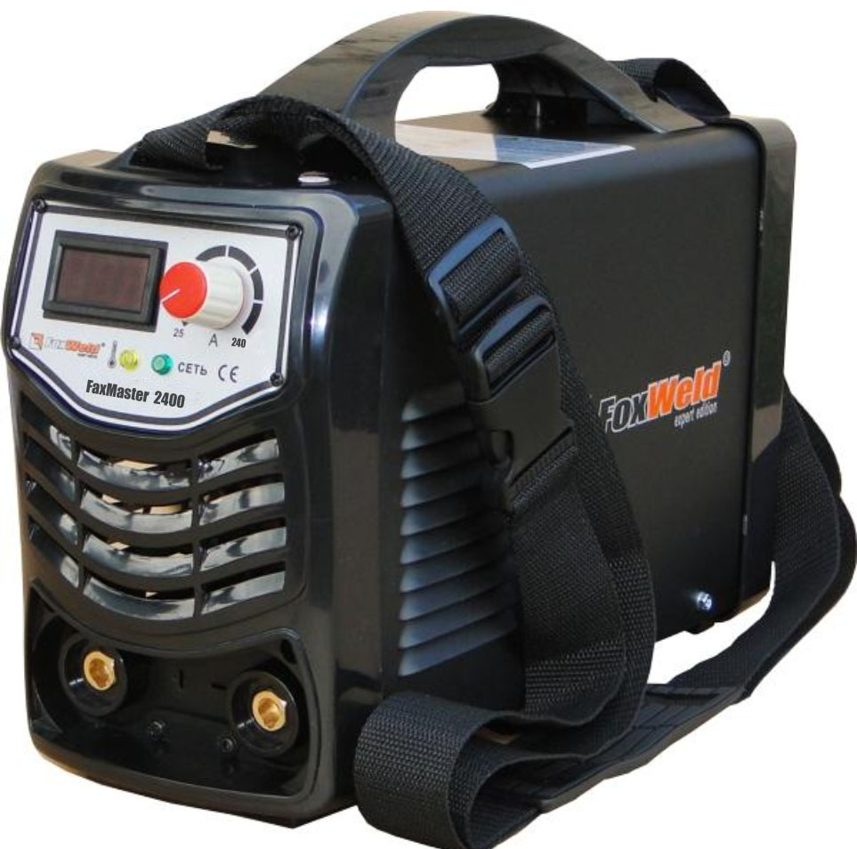

主要配件列表：

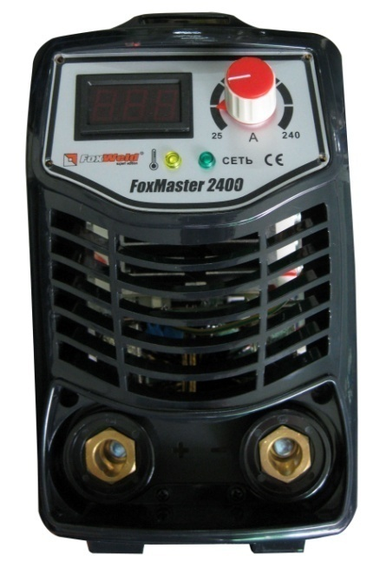 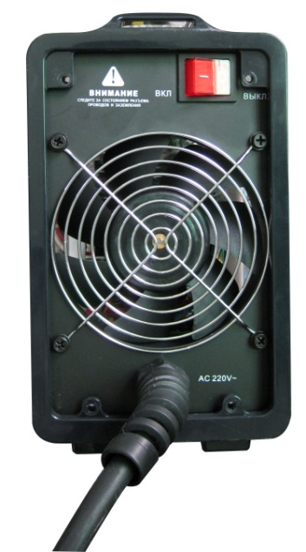

**10**

**2**

**2**

**3**

**9**

**8**

**7**

**6**

**4**

**5**

**1**

|  |  |  |  |  |
| --- | --- | --- | --- | --- |
| NUMBER | SERIAL NUMBER | COMMENT | Specifications and models | Photo |
| 0 | 1303121400026 | cover-RS-SV | H214-02(A0) |  |
| 1 | 2230023001001 | DIGITAL READOUT METER | LXD5130-1V | C:\Documents and Settings\chenyanhui\桌面\rs-sv\OK\LXD5130.jpg |
| 2 | 2239010003003 | LAMP COVER | Φ3/ Green | 红绿 |
| 2239010003004 | LAMP COVER | Φ3/ yellow |
| 2106040305001 | LED | Φ3/ Green |
| 2106040306001 | LED | Φ3/ yellow |
| 3 | 1331010000043 | FRONT PANEL | 140 Type (Black) |  |
| 4 | 2227080050002 | FAST SOCKET | KDZ-50A | 插座 |
| 5 | 2238010110003 | KNOB | XN-110ZRED |  |
| 2102131030703 | POTENTIOMETER | 2W10K/RV28P-B103-16 |  |
| 6 | 1331010000042 | back panel -plastic | 140 Type (Black) |  |
| 7 | 2235010120001 | FAN NET | 120 Type | C:\Documents and Settings\chenyanhui\桌面\111\120W.png |
| 8 | 2243010022002 | WIRE KNOT | M22 Black | C:\Documents and Settings\chenyanhui\桌面\111\M22.png |
| 9 | 1103320340309 | INPUT POWER LINE WITH PLUG | 3X4MM2/3M |  |
| 10 | 2229010016004 | POWER SWITCH | 16A/250V/KCD2-21 | C:\Documents and Settings\chenyanhui\桌面\111\KGRED.png |

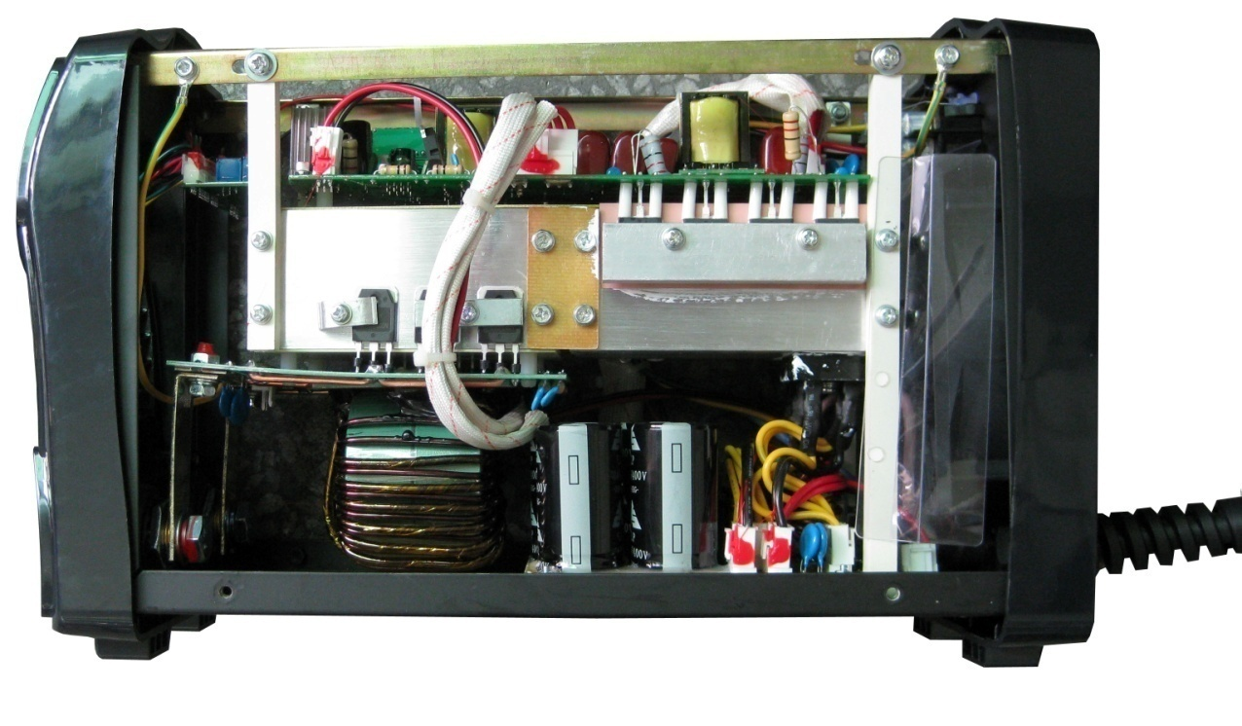

**11**

**12**

**13**

**14**

**15**

**16**

**17**

**18**

|  |  |  |  |  |
| --- | --- | --- | --- | --- |
| NUMBER | SERIAL NUMBER | COMMENT | Specifications and models | Photo |
| 11 | 1307128300004 | FRONT AND RIGHT RADIATOR | H283-00-07(A1) |  |
| 1307128300003 | FRONT AND LEFT RADIATOR | H283-00-06(A1) |
| 12 | 1102021821203 | MIDDLE BOARD | HDB-182-A2(03) | E:\客户资料\PCB板图\图片\1376776551084_旋转.jpg |
| 13 | 1102031701203 | BOTTOM BOARD | HZB-170-A2(03) |  |
| 14 | 1103013500012 | SILICON BRIDGE LINE | S35VB100/4V4-100/5V4-100/3V1-150 | C:\Documents and Settings\chenyanhui\桌面\rs-sv\OK\硅桥25A.jpg |
| 15 | 1307128300002 | BACK AND RIGHT RADIATOR | H283-00-05(A1) |  |
| 1307128300001 | BACK AND LEFT RADIATOR | H283-00-04(A1) |
| 16 | 2310000000004 | Tablet | 38\*10\*2.5/PM4\*16 |  |
| 17 | 1102011814001 | TOP BOARD | HMB-181-T0(01) |  |
| 18 | 1312128300001 | CROSSGIRDER | H283-00-01(A1) |  |

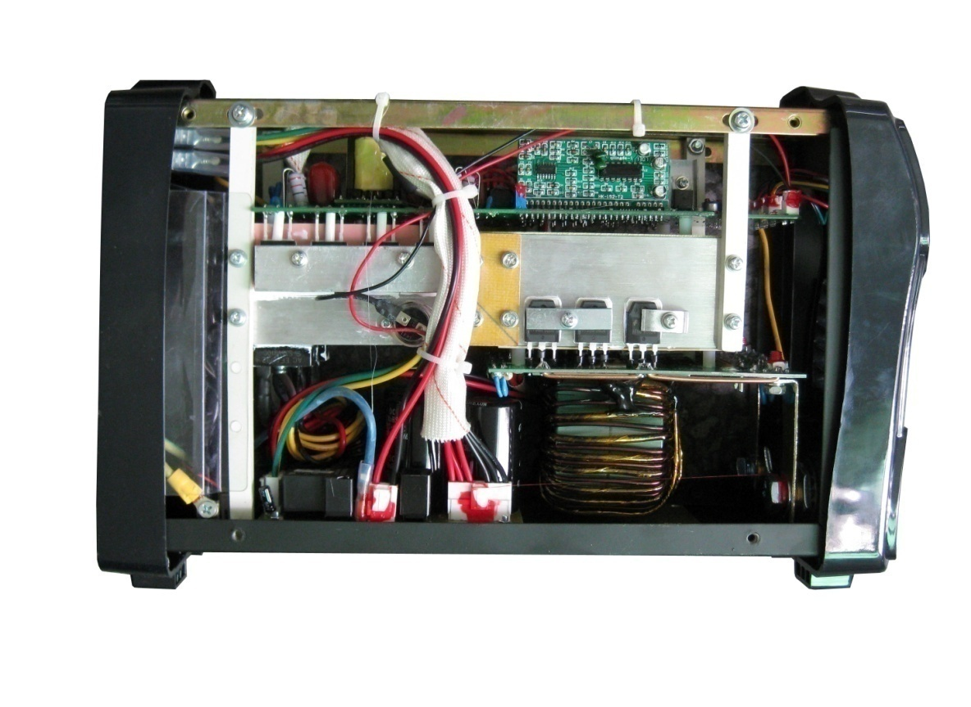

**23**

**22**

**21**

**19**

**20**

|  |  |  |  |  |
| --- | --- | --- | --- | --- |
| NUMBER | SERIAL NUMBER | COMMENT | Specifications and models | Photo |
| 19 | 2122010080002 | Thermal Switch | KI31-80℃±3℃-K |  |
| 20 | 1103080300105 | FAN LINE | 120type 24V/B34978-16 |  |
| 21 | 2303128300002 | UPRIGHT 2 | H283-00-03(A0) |  |
| 22 | 2303128300001 | UPRIGHT 1 | H283-00-02(A0) |  |
| 23 | 1102001381001 | FAN BOARD | HHB-138-A0(01) |  |

**[12] MIDDLE BOARD -- HDB-182-A2(03)（1102021821203）**

**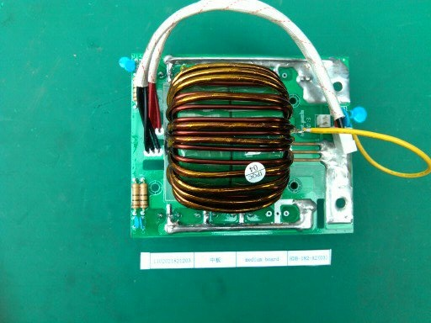**

**24**

**25**

|  |  |  |  |  |
| --- | --- | --- | --- | --- |
| NUMBER | SERIAL NUMBER | COMMENT | Specifications and models | Photo |
| 24 | 2106030603001 | fast recovery diode | FF60UP30DN |  |
| 25 | 2113022040003 | main transformer | 20:4(T63\*38\*25\*2P) J61-20(A0)/ |  |

**[13] BOTTOM BOARD -- HZB-170-A2(03)（1102031701203）**

**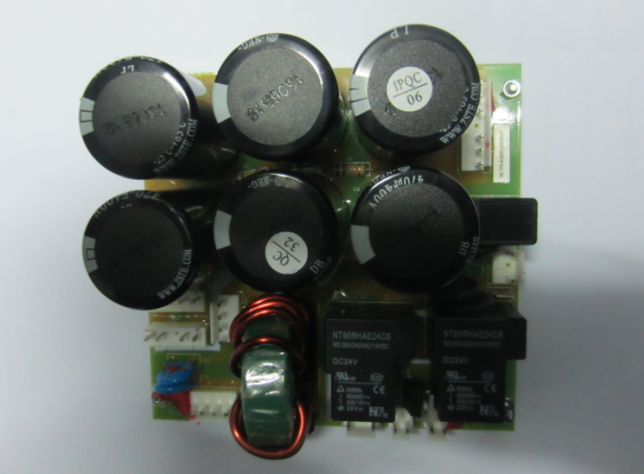**

**26**

**30**

**29**

**28**

**27**

|  |  |  |  |  |
| --- | --- | --- | --- | --- |
| NUMBER | SERIAL NUMBER | COMMENT | Specifications and models | Photo |
| 26 | 2103014771004 | aluminum electrolytic capacitor | CD-470u-400V（85C/30X50/10.0/±20%） | 470  400v 85c 50 |
| 27 | 2102100016002 | Thermistor | PTC-SY16P（4R） |  |
| 28 | 2102104715002 | thermistor | NTC-47D-15 | C:\Documents and Settings\chenyanhui\Application Data\Tencent\Users\53982482\QQ\WinTemp\RichOle\YHO2]83CB}1~FP5ZRXM~XVD.jpg |
| 29 | 2120010024011 | relay | 24V30A/NT90RHAE24CB | D:\My Documents\继电器30A 240V.jpg |
| 30 | 2108010024001 | MOSFET | IRFZ24N/IR | IRFZ24V |

**[17] TOP BOARD -- HMB-181-T0(01)(1102011814001)**

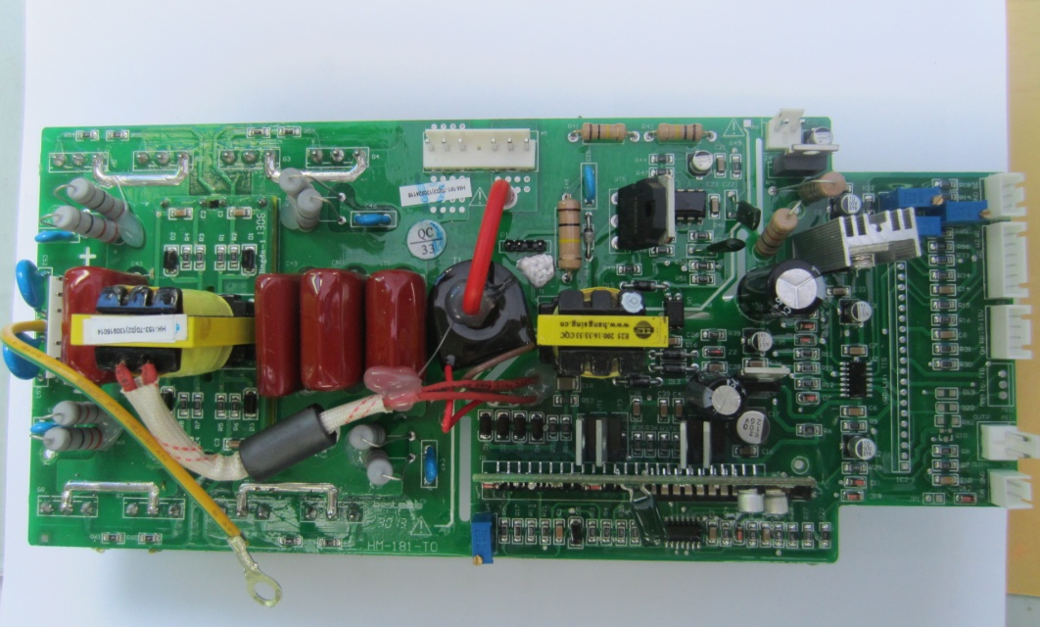

**41**

**37**

**33**

**34**

**35**

**36**

**38**

**39**

**40**

**32**

**31**

|  |  |  |  |  |
| --- | --- | --- | --- | --- |
| NUMBER | SERIAL NUMBER | COMMENT | Specifications and models | Photo |
| 31 | 2109010406001 | IGBT | FGH40N60SFD | C:\Documents and Settings\chenyanhui\桌面\111\40N60.png |
| 32 | 1102041534002 | Driver module board | HKB-153-T0(02) |  |
| 33 | 2108010924001 | mosfet | IRF9Z24N/IR |  |
| 34 | 2108010024001 | mosfet | IRFZ24N/IR | IRFZ24V |
| 35 | 1102041524201 | control modual | HKB-152-T2(01) |  |
| 36 | 2107017915001 | IC | KA7915TU/FSC |  |
| 37 | 2107017815001 | IC | KA7815TU/FSC |  |
| 38 | 2107017805001 | IC | KA7805TU/FSC |  |
| 39 | 2107013843001 | IC | TL3843p TI |  |
| 40 | 2108013878002 | MOSFET | 2SK3878/STA1.E.S | D:\My Documents\K3878.jpg |
| 41 | 2113062001001 | Auxiliary power transformer | 200：16：33：33 (HS21318/03) EEL-25 |  |

主机接线图：

